Week 3 – Mandatory Hands-On Exercises Part 2

1. Spring Data JPA quick example
2. application.properties

logging.level.org.springframework=info

logging.level.com.cognizant=debug

logging.level.org.hibernate.SQL=trace

logging.level.org.hibernate.type.descriptor.sql=trace

logging.pattern.console=%d{dd-MM-yy} %d{HH:mm:ss.SSS} %-20.20thread %5p %-25.25logger{25} %25M %4L %m%n

spring.datasource.url=jdbc:mysql://localhost:3306/ormlearn

spring.datasource.username=root

spring.datasource.password=root

spring.datasource.driver-class-name=com.mysql.cj.jdbc.Driver

spring.jpa.hibernate.ddl-auto=validate

spring.jpa.properties.hibernate.dialect=org.hibernate.dialect.MySQL5Dialect

1. Create MySQL Table and Data

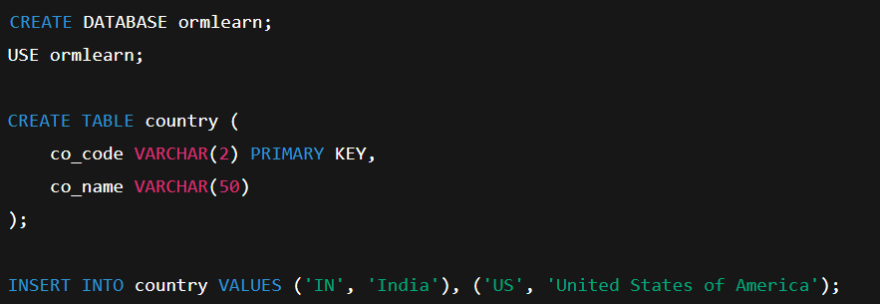

1. Create Country.java

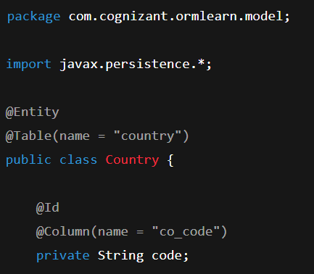

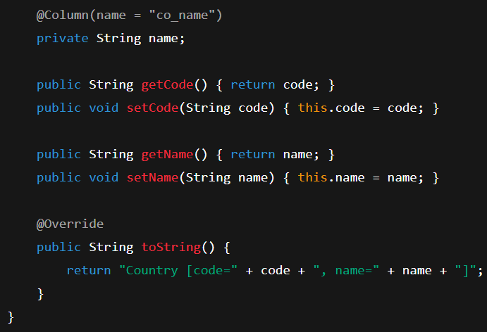

1. Repository Interface

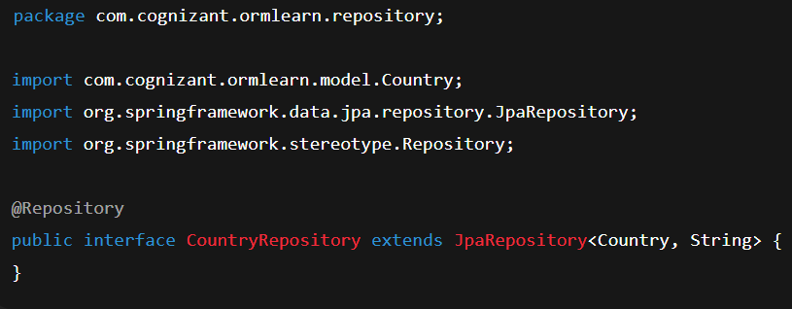

1. Service Class

package com.cognizant.ormlearn.service;

import com.cognizant.ormlearn.model.Country;

import com.cognizant.ormlearn.repository.CountryRepository;

import org.springframework.beans.factory.annotation.Autowired;

import org.springframework.stereotype.Service;

import org.springframework.transaction.annotation.Transactional;

import java.util.List;

@Service

public class CountryService {

@Autowired

private CountryRepository countryRepository;

@Transactional

public List<Country> getAllCountries() {

return countryRepository.findAll();

}

}

1. Main Class

package com.cognizant.ormlearn;

import com.cognizant.ormlearn.model.Country;

import com.cognizant.ormlearn.service.CountryService;

import org.slf4j.Logger;

import org.slf4j.LoggerFactory;

import org.springframework.boot.SpringApplication;

import org.springframework.boot.autoconfigure.SpringBootApplication;

import org.springframework.context.ApplicationContext;

import java.util.List;

@SpringBootApplication

public class OrmLearnApplication {

private static final Logger LOGGER = LoggerFactory.getLogger(OrmLearnApplication.class);

private static CountryService countryService;

public static void main(String[] args) {

ApplicationContext context = SpringApplication.run(OrmLearnApplication.class, args);

LOGGER.info("Inside main");

countryService = context.getBean(CountryService.class);

testGetAllCountries();

}

private static void testGetAllCountries() {

LOGGER.info("Start");

List<Country> countries = countryService.getAllCountries();

LOGGER.debug("countries={}", countries);

LOGGER.info("End");

}

}

Output:

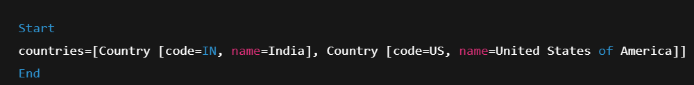

1. Difference between Hibernate and Spring Data JPA

| **Technology** | **Role** | **Code Sample** |
| --- | --- | --- |
| **JPA** | Specification only (no impl) | Uses @Entity, @Id, @Column |
| **Hibernate** | ORM tool + JPA implementation | Uses SessionFactory, Session, save() |
| **Spring Data JPA** | Spring abstraction over JPA + Hibernate | Uses JpaRepository.save() with no boilerplate |

Example for Hibernate

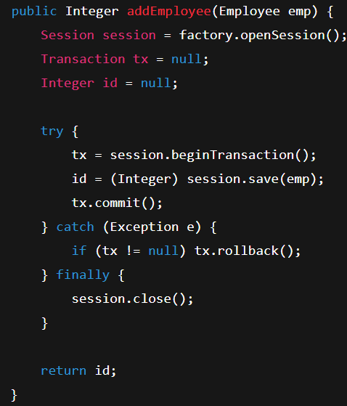

Spring Data JPA Code Equivalent for above Hibernate Code :

